“Have you signed yours?” Button and Sticker
Talking Points for Volunteers and Staff

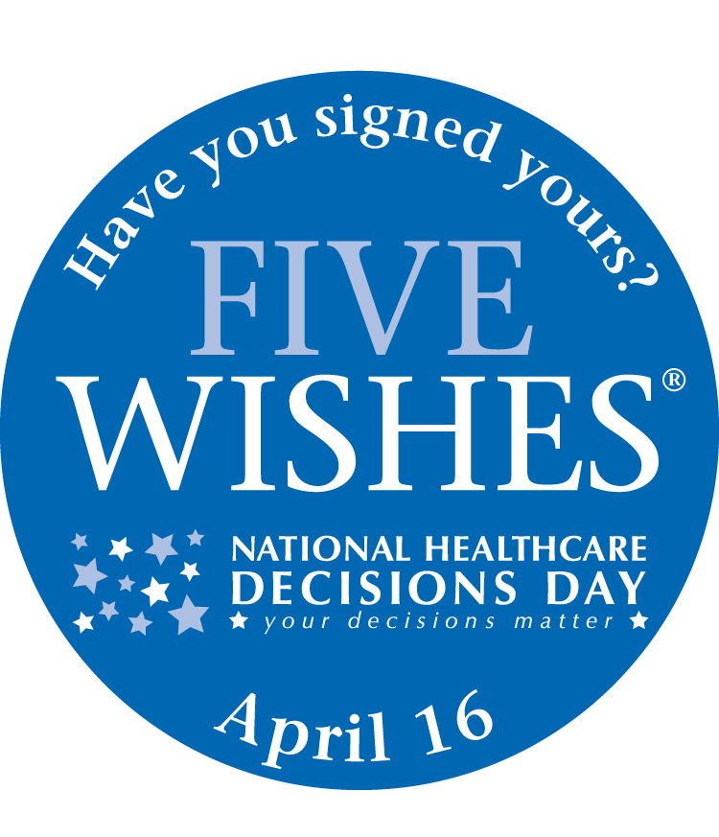
Every day you interact with family, friends, and neighbors who may not know about the work we do. In observance of National Healthcare Decisions Day April 16, we are asking a few of our experienced staff and volunteers to help us share the value of our organization and promote the importance of advance care planning.

Please review this information before wearing your button or sticker so you can respond to questions. If you don’t feel comfortable wearing these items, please return them to a staff member and we’ll ask someone else to wear them. If you have questions, please call or email me.

Why are we using these buttons and stickers?
The “Have You Signed Yours? buttons and stickers are designed as a way to talk to people about the great work we do and the importance of advance care planning. Our organization uses the Five Wishes program, which includes an advance directive and the people at Five Wishes sent us these items to use.

When and where should I wear the buttons and stickers?
Wearing the buttons or stickers is a great way to engage people in conversations about advance care planning. Please wear the buttons when you are out in the community and have the time to talk about advance care planning. Since you will be representing our organization, we ask that you only wear the button or sticker if you are dressed neatly and can represent the organization in a professional manner.

What is advance care planning?
Advance care planning is the process of communication between an individual and his or her healthcare agent to understand, discuss, and plan for future healthcare decisions in the event the individual is unable to make his or her own healthcare decisions.

What should I say when someone asks, “Have You Signed Yours?”
The “Have You Signed Yours?” button and stickers prompt people to ask you about this issue so you can ask them if they have an advance directive. Our organization also helps people at all stages of life to think about, discuss, and document their wishes in the event they become seriously ill. We provide Five Wishes to do this, giving away hundreds of documents each year.

What is Five Wishes?
Five Wishes is an advance care planning program with an easy-to-use legal document written in everyday language that lets adults of all ages plan how they want to be cared for in case they become seriously ill. Five Wishes helps you express how you want to be treated if you are seriously ill and unable to speak for yourself. It is unique among all other living will and health agent forms because it speaks to all a person's needs: medical, personal, emotional, and spiritual.

What should I do if someone wants more information?
If possible, ask if you can take their name, phone number, and/or email address and let them know that someone from hospice will be in touch with them within the next 2 days. If they need immediate assistance, or if they aren’t comfortable giving you their name and contact information, give them our main phone number.
- If they are interested in learning about how to get hospice for a family member or friend, instruct them to ask for a staff member when they call.
- If they would like a free Five Wishes document mailed to them, tell them to ask for a staff member.
- If they are interested in volunteering for our organization, refer them to the volunteer manager.
- For those interested in applying for a job with our organization, refer them to the human resources director.

